# Rebroadcasting packet in NetSim MANET\VANETs

**Software:** NetSim Standard v13.3, Microsoft Visual Studio 2022

**Project Download Link:**

Follow the instructions specified in the following link to download and setup the Project in NetSim:

[https://support.tetcos.com/en/support/solutions/articles/14000128666-downloading-and-setting-up-netsim-file-exchange-projects](https://support.tetcos.com/support/solutions/articles/14000128666-downloading-and-setting-up-netsim-file-exchange-projects)

## **Broadcasting**

Broadcasting is the process of sending a message from one node to all other nodes in an ad-hoc network. It is a fundamental operation for communication in ad-hoc networks as it allows for the update of network information and route discovery at every node.

## **Rebroadcasting**

It is the process of broadcasting the received message to all the other nodes in the ad-hoc network.

## **MANET SCENARIO**

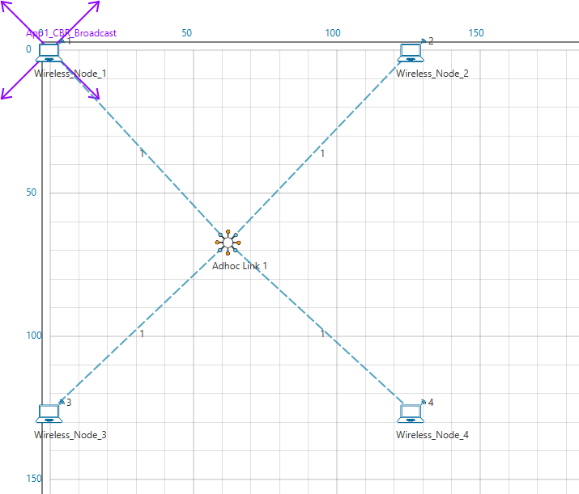

Figure 1: Network Scenario created in MANET

Wireless Node 1 initiates a broadcast message, and the message is received by nodes 2, 3 and 4. 2, 3 and 4 rebroadcast the message if they have not broadcasted that before. Furthermore, this implementation involves a Rebroadcast_Probability based on which the nodes resend the packets.

**Probability-based rebroadcasting** - The decision of rebroadcasting is based upon a random probability. This probability may be as simple as flipping a coin or it may be very complex involving probabilities which include parameters such as node density, duplicate packets received, battery power or a particular nodes participation within the network etc. Users can change the Rebroadcast_Probability macros present in Rebroadcast.c file as shown below:

Figure 2: Rebroadcast Probability

## **Rebroadcasting in NetSim**

To implement this project in NetSim, we have created an additional **Rebroadcast.c** file inside Application project. The file contains the following functions:

* **void rebroadcast_packet();** //This function is used to rebroadcast the packet.
* **static bool isRebroadcastAllowed();** //This function is used to check whether rebroadcasting is allowed or not.
* **void rebroadcast_add_packet_to_info();** //This function is used to add the packet to rebroadcast list.
* **static void cleanup_broadcast_info();** //This function is used to clean the broadcast information.

# Example

1. The Workspace_MANET_VANET_Rebroadcast comes with a sample network configuration that are already saved. To open this example, go to Your work in the home screen of NetSim and click on the **Rebroadcast_VANET_Example/Rebroadcast_MANET_Example** from the list of experiments.
2. Run the simulation for 100 seconds.

## **VANET SCENARIO**

Figure 4: Network Scenario created in VANET

## **Results and discussion**

* In the above scenario, Vehicle-1 is broadcasting the packet and it is received by the Vehicles 2, 3, 4 and 5. Then Vehicles 2, 3, 4 and 5 will rebroadcast the same packet based on the probability value in Rebroadcast.c file.
* After simulation, open Packet Trace and filter Packet_Id to ‘1’ or any other id and observe that the nodes other than source are rebroadcasting the same packet.

Figure 5: NetSim Packet Trace

* The same can be observed in MANET Example.
* Note that Users SHOULD NOT use the performance metrics provided at the end of simulation but should rather calculate the network performance metrics from the packet trace.
* Users can also create their own network scenarios in **Single MANET/VANET** and run the simulation.

## **Appendix: NetSim source code modifications**

**Changes to handle_app_out() function, in APP_OUT.c file, within Application project**

/*The code checks if the destination is ‘0’ i.e., Broadcast packet, then it adds the packet to rebroadcast list*/

//Fragment the packet

int nSegmentCount = 0;

double segmentsize = fn_NetSim_Stack_GetMSS(pstruPacket);

nSegmentCount = fn_NetSim_Stack_FragmentPacket(pstruPacket, (int)fn_NetSim_Stack_GetMSS(pstruPacket));

// ADD REBROADCAST

#ifdef REBROADCAST

if (appInfo->sourceList[0] == pstruEventDetails->nDeviceId)

#endif // REBROADCAST

set_app_end_and_generate_next_packet(pstruPacket, otherDetails, destCount, dest);

//Add the dummy payload to packet

fn_NetSim_Add_DummyPayload(pstruPacket, appInfo);

#ifdef REBROADCAST

if (appInfo->sourceList[0] == pstruEventDetails->nDeviceId)

#endif // REBROADCAST

appmetrics_src_add(appInfo, pstruPacket);

appout_send_packet(s, appInfo, pstruPacket, nDeviceId);

#ifdef REBROADCAST

if (!dest[0])

rebroadcast_add_packet_to_info(pstruPacket, pstruEventDetails->dEventTime);

#endif // REBROADCAST

}

**Changes to int fn_NetSim_Application_Run()function in the APPLICATION_IN_EVENT, in Application.c file, within Application project**

/* It checks whether the destination is ‘0’ or not. If it is ‘0’, then it rebroadcasts the packet or else deletes the packet.*/

#ifdef REBROADCAST

if (pstruappinfo->sourceList[0] == pstruPacket->nSourceId)

#endif // REBROADCAST

appmetrics_dest_add(pstruappinfo, pstruPacket, pstruEventDetails->nDeviceId);

if(pstruappinfo->nAppType==TRAFFIC_PEER_TO_PEER && pstruPacket->pstruAppData->nAppEndFlag==1)

{

fn_NetSim_Application_P2P_MarkReceivedPacket(pstruappinfo,pstruPacket);

fn_NetSim_Application_P2P_SendNextPiece(pstruappinfo,get_first_dest_from_packet(pstruPacket),pstruEventDetails->dEventTime);

}

if(pstruappinfo->nAppType == TRAFFIC_EMULATION && pstruPacket->szPayload)

{

fn_NetSim_Dispatch_to_emulator(pstruPacket);

}

if (pstruappinfo->nAppType == TRAFFIC_BSM_APP)

{

process_saej2735_packet(pstruPacket);

}

#ifdef REBROADCAST

UINT destCount;

NETSIM_ID* dest = get_dest_from_packet(pstruPacket, &destCount);

if (!dest[0])

{

rebroadcast_packet(pstruPacket,

pstruEventDetails->nDeviceId,

pstruEventDetails->dEventTime);

}

else

{

#elif

//Delete the packet

fn_NetSim_Packet_FreePacket(pstruPacket);

#endif // REBROADCAST

#ifdef REBROADCAST

}

**Added the following function declarations in Application.h file, within Application project**

int fn_NetSim_Add_DummyPayload(NetSim_PACKET* packet, ptrAPPLICATION_INFO);

//Encryption

char xor_encrypt(char ch, long key);

int aes256(char* str, int* len);

int des(char* buf, int* len);

//Application event handler

void handle_app_out();

#define REBROADCAST

void rebroadcast_add_packet_to_info(NetSim_PACKET* packet, double time);

void rebroadcast_packet(NetSim_PACKET* packet, NETSIM_ID devId, double time);

#endif